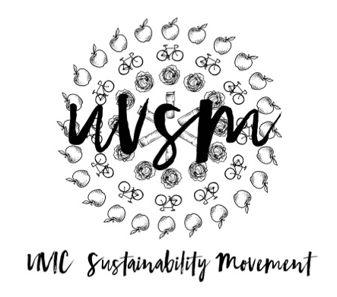

Annual General Meeting Agenda

September 21, 2017

5:00 PM
Type of Meeting: Annual General Meeting
Location: Room B028, SUB
Meeting Facilitator: Devon Goldie
Attendance:
- Call to order
- Acknowledgement of Traditional Territories
Recognizing we are visitors on the traditional unceded Coast Salish territories (Lekwungen & W̱SÁNEĆ peoples)
- Introductions and Check In
- Overview of 2016/2017
  - Staff
  - Board of Directors
  - Rebranding
  - Grants
  - Campaigns
    - Love My Mug Campaign
    - Compost Campaign
    - Eat Less Red Meat Campaign
  - SPUD Food Box
  - Garden Plot
  - Green Screens Movie Nights
- Election/Appointment of New Board Members
  - Any general member of the UVS[M] who attends three [3] UVS[M] director's meetings shall become a UVS[M] director and shall have voting rights.
  - Positions to be elected:
    - Chair
    - Secretary
    - Treasurer
- Sub-committees
- Signing Authorities
- Things coming up this year:
  - Board of Directors Retreat – October
  - Monthly Movie Night
    - September Movie Night – Tuesday, September 26, 2017
Vertigo, 6:30-8:30 PM
Banana Land: Blood, Bullets, and Poison (for Fair Trade Week)
Free Pizza
  - Expanding SPUD Food Box program
  - Continuing Campaigns
  - UVERT – Uvic Environmental Round Table
    - Thursday, October 12, 2017
Michelle Pujol Room, 5:30-8:30 PM
Free Dinner
  - Workshops
    - Make Your Own Laundry Detergent
    - Make Your Own Deodorant
  - Tours of Local, Sustainable Initiatives (ie. Level Ground Trading)
  - Pub Crawl with The Rolling Barrel – Spring semester
- Brainstorming/Dreaming
- Adjournment

