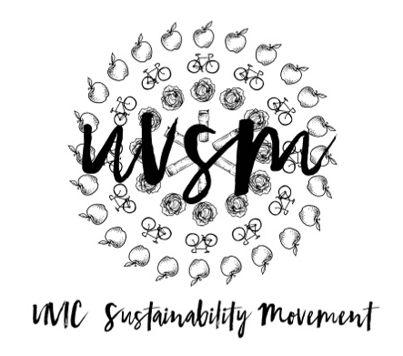

Board Meeting Agenda

February 5, 2018

5:30 PM
Type of Meeting: Board of Directors
Location: Room B118, SUB
Meeting Facilitator: Devon Goldie
Attendance: Nicole, Jessie, Devon, Kaia, Ryan
- Call to order – 5:34 PM
- Acknowledgement of Traditional Territories
Recognizing we are visitors on the traditional unceded Coast Salish territories (Lekwungen & W̱SÁNEĆ peoples)
- Check In
- Program Updates
  - Finance & Grants
    - Paperwork to sign
  - SPUD Food Box / Garden
    - SPUD concerns? Should we look into moving over to the Good Food Box?
    - Saanich Organics $30? Possibly a lower student price? (bi-weekly in the off-season)
  - Events (Movie Nights, Workshops, etc.)
    - Canadian Fairtrade Network Conference – tickets booked.
      - How much will UVSM cover vs. folks pay?
        - 80% of cost covered by the UVSM and 20% by board members/staff. $75 for three days and $70 for two days. APPROVED.
      - How are we getting there? Ryan, Josh, Breanna, and Naomi in one vehicle on Friday morning. Friday evening bussing - Vincent, Kaia, Nicole, and Catie. Devon bussing on Saturday morning.
    - Explore UVic – February 17 from 8-4. Prospective high school & transfer students exploring UVic and they want us to be there. Is anyone interested in helping table? Ryan 8 AM - 12 PM.
  - Campaigns
    - Love My Mug/Change the Cup
      - ES 415 group project
      - To do:
        - Finish Petition
          - Read and edit draft (uploaded on the Facebook group)
        - Business Plan
        - Video – Ryan update
        - Table outside the library after reading break
        - Get Res Green Team to promote
        - The UVSS wants to give away out mugs their SAGM (Thursday at 3 PM) as incentive to get people to come to the meeting. We can put stickers on them and we could also set up at the meeting and ask for petition signatures. Can we make a speech? Message Dale. Dana, Devon.
        - The CCG is running a Pop-Up Market in front of the library in February with free veggies and tea. They offered to let us give away mugs for the tea and run our petition. 11-1 on Thursday.
  - Media
- Other ideas/thoughts
- Adjournment – 6:21 PM

