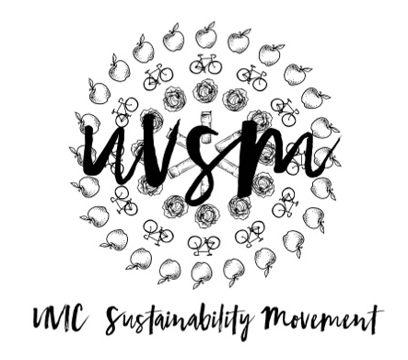

Board Meeting Agenda

January 23, 2018

3:30 PM
Type of Meeting: Board of Directors
Location: Room B025, SUB
Meeting Facilitator: Devon Goldie
Attendance:
- Call to order –
- Acknowledgement of Traditional Territories
Recognizing we are visitors on the traditional unceded Coast Salish territories (Lekwungen & W̱SÁNEĆ peoples)
- Check In
- Program Updates
  - Finance & Grants
    - No updates
  - SPUD Food Box / Garden
    - Devon needs someone to run the Food Boxes this Wednesday from 1-3 because she has a prior commitment.
  - Events (Movie Nights, Workshops, etc.)
    - Rolling Barrel Pub Crawl
      - What date and time do we prefer? The options are 12 PM, 3 PM, 3 PM, or 9 PM on any of the following days:|
March 4 or any day from March 18-31, 2018
  - Campaigns
    - Love My Mug/Change the Cup
      - To do:
        - Finish Petition
          - Read and edit draft (uploaded on the Facebook group)
        - Business Plan
        - Video – Ryan update
        - The UVSS wants to give away out mugs their SAGM as incentive to get people to come to the meeting. We can put stickers on them and we could also set up at the meeting and ask for petition signatures.
        - The CCG is running a Pop-Up Market in front of the library in February with free veggies and tea. They offered to let us give away mugs for the tea and run our petition there as well.
  - Media
    - No updates
- Other ideas/thoughts
- Adjournment –

