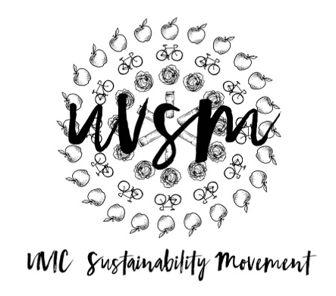

Board Meeting Agenda

March 19, 2018

5:30 PM
Type of Meeting: Board of Directors
Location: Hallway, SUB
Meeting Facilitator: Devon Goldie
Attendance: Nicole, Naomi, Ryan, Josh, Vincent
- Call to order – 5:39 PM
- Acknowledgement of Traditional Territories
Recognizing we are visitors on the traditional unceded Coast Salish territories (Lekwungen & W̱SÁNEĆ peoples)
- Check In
- Program Updates
  - Finance & Grants
    - Paperwork
  - SPUD Food Box / Garden
    - When to end SPUD for the summer? End of the semester.
    - SPUD next year
      - Meet with SPUD about problems
      - Look into Good Food Box
  - Events (Movie Nights, Workshops, etc.)
    - Earth Fest for September
      - Ideas:
        - Over Sustainability Work
        - Free concert – Luke Wallace, Electric Sex Panthers
        - Free food. Maybe collab with the cabbage and/or the garden?
        - Mark you own laundry detergent workshop
        - Make your own potted plant?
        - Seed paper card making
        - Edible plant workshop
        - Green movie in the quad? Wall-e! Snack station.
        - Email OCPS
  - Campaigns
    - Love My Mug/Change the Cup
      - ES 415 group project update
      - Levi – video idea. APPROVED.
      - Where do we go from here?
        - Meeting with Residence Services. Ryan will contact.
        - Meeting with the UVSS Board of Directors about the SUB – Email Dale. First week of April.
        - Stunt/prank – Signs on the trees
        - Chalking
        - Print Infographic
  - Media
- Other ideas/thoughts
- Adjournment –

