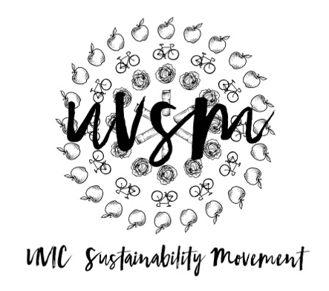

Board Meeting Agenda

March 5, 2018

5:30 PM
Type of Meeting: Board of Directors
Location: Room B118, SUB
Meeting Facilitator: Devon Goldie
Attendance: Nicole, Jessie, Devon, Kaia, Ryan
- Call to order – 5:34 PM
- Acknowledgement of Traditional Territories
Recognizing we are visitors on the traditional unceded Coast Salish territories (Lekwungen & W̱SÁNEĆ peoples)
- Check In
- Program Updates
  - Finance & Grants
  - SPUD Food Box / Garden
  - Events (Movie Nights, Workshops, etc.)
    - Earth Fest for September
  - Campaigns
    - Love My Mug/Change the Cup
      - ES 415 group project
      - To do:
        - Table tomorrow at the fountain – 9:30-3:30
        - Keep social media campaign going
        - Press Release?
        - Plant Paper for promo materials
        - TVs in SUB and around campus
        - Event night – like Pints for Pipelines (draw to win a free beer, performers, speakers)
        - Sticker campus – bathrooms, garbage cans, benches, bus stops, backs of chairs in classrooms
        - Chalking campus!
        - Cup Drop? Off SUB or Library? Ask Levi?
        - $5 back when you return a bin of cups.
        - Collect reusable cups from students on moving day.
        - Promote to other clubs and departments (ES, Geography, Sciences, Fine Arts, Anthropology, Philosophy, Engineering – Ryan’s Dad, Poli Sci)
        - Business Plan
        - Video – Ryan update
  - Media
- Other ideas/thoughts
- Adjournment – 6:46 PM

