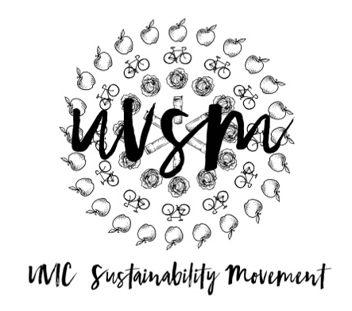

Board Meeting Agenda

November 6, 2017

5:30 PM
Type of Meeting: Board of Directors
Location: Room B028, SUB
Meeting Facilitator: Devon Goldie
Attendance: Catie, Nicole, Joshua, Breanna, Kaia, Ryan, Josh, Jamie,
- Call to order – 5:33 PM
- Acknowledgement of Traditional Territories
Recognizing we are visitors on the traditional unceded Coast Salish territories (Lekwungen & W̱SÁNEĆ peoples)
- Check In
- Program Updates
  - Finance & Grants
  - SPUD Food Box / Garden
  - Don’t Eat Red Meat
  - Events (Movie Nights, Workshops, etc.)
    - Movie Night
      - An Inconvenient Sequel review
      - Do we want to do a November movie night? Nope.
      - Seed for January?
  - Campaigns
    - Love My Mug/Change the Cup
      - What happened at our Sunday gathering:
        - Revised logo
        - Stickers ordered
        - Drafted petition layout
        - Budget – we have about $17,000 left in our annual budget.
        - Ozzi update
          - Goal level – McGill. Precedent across North America.
          - Meeting with representatives and uni administration.
          - Fly the Ozzi guy in from Rhode Island, NY. On November 21, 2017. Walk in.
          - Josh will talk to NSU and Food Services.
        - Video update
          - Tuesday, November 21st, 2017 at 9 AM. Want it up and to the media within a week. We are diverting compostable cups from the landfill. Need hard hats and work boots for people going onto the landfill.
          - Plexiglas art installation with all the cups in it
          - Mike the videographer is on board!
          - Hartland wants to help us
      - To do:
        - Teams:
          - Petition
            - Devon, Jamie, Kaia, Joshua
            - What platform do we want to use? Change.org? LeadNow?
            - Release with film?
          - Business Plan
            - Josh, Breanna
          - Promotion
            - Devon, Nicole, Catie,
            - Put new stickers on current mugs – next week?
            - Organize classroom talks
            - Snapchat
            - Posters?
            - Media Release? Martlet?
            - Can/should we co-promote Divest UVic? Support one another?
          - Video
            - UVic Filming at 10:30 AM
- Collect cups
- Walking around campus
- Lighter facts
- End note shot: Rewind shot and alternatives/what we want. Reusable mugs and a call to Change the Cup!
Garbage Truck filming at 12:30 PM
- Ryan in truck with Selfie Stick
- Movement footage
Hartland Landfill at 1:30 PM
- Get out of truck
- Hard hitting facts
            - Stop motion with photos to follow garbage truck
            - First shot is someone throwing a paper cup. Have you ever thought about what happens to your cup when you throw it in the garbage? End shot is same person walking past with a reusable mug.
            - What can you do instead? You can use a reusable mug and support our cause! We are calling UVic to Change the Cup!
            - Should let the Martlet know. Invite someone to filming.
            - Hartland is supporting us and sponsor us.
  - Media
    - Send me sustainability memes
- Other ideas/thoughts
- Adjournment – 6:37 PM

