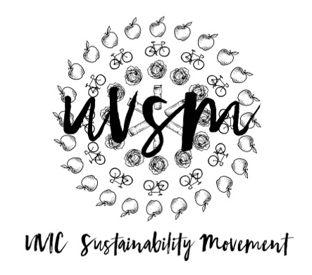

Board Meeting Agenda

November 27, 2017

5:30 PM
Type of Meeting: Board of Directors
Location: Room B028, SUB
Meeting Facilitator: Devon Goldie
Attendance:
- Call to order
- Acknowledgement of Traditional Territories
Recognizing we are visitors on the traditional unceded Coast Salish territories (Lekwungen & W̱SÁNEĆ peoples)
- Check In
- Volunteer Appreciation
  - Brunch – Bubby’s? Floyd’s? Saturday at 10 AM.
- Program Updates
  - Finance & Grants
  - SPUD Food Box / Garden
  - Don’t Eat Red Meat
  - Events (Movie Nights, Workshops, etc.)
    - Bike Pub Crawl next semester - January
  - Campaigns
    - Love My Mug/Change the Cup
      - Update
        - Trailer for the video?
      - Release date TBD
      - To do:
        - Write Petition
        - Business Plan
        - Promotion
          - Stickers
          - Classroom talks
          - Snapchat
          - Posters
          - Media Release – everyone!
          - New Year’s Resolution – Bring your own mug
          - UVSS Board
            - Email all executives
        - Stakeholder meeting – January
  - Media
    - Send me sustainability memes
    - Sustainable DIY gift ideas!
    - Make memories, not trash
- Other ideas/thoughts
- Adjournment

