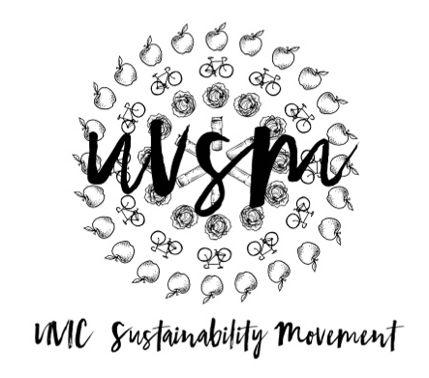

Board Meeting Agenda

October 23, 2017

5:30 PM
Type of Meeting: Board of Directors
Location: Room B028, SUB
Meeting Facilitator: Devon Goldie
Attendance:
- Call to order – 5:34 PM
- Acknowledgement of Traditional Territories
Recognizing we are visitors on the traditional unceded Coast Salish territories (Lekwungen & W̱SÁNEĆ peoples)
- Check In
- Next Sunday get together
  - Starting at 12 PM
  - Find a mug company to donate to us for petition
  - Draft petition – Make a final statement
  - Figure out what system we are proposing. Must be automated.
  - Washing station in coffee shops?
  - Promotion ideas/marketing strategy/Propaganda
    - Boost video
    - Competition: Conservatives
    - Posters on garbage cans – we have permission
    - Logo – recycling symbol around the cup
  - Press Release to media
  - By Wednesday can we implement the petition? Have people from the Green Team standing in front of garbage’s.
  - Consulting with the First Nations – NSU. First People’s House. We want consent – what do you think we should do? Ryan and Devon and Ryan’s Dad go to First People’s house tomorrow morning.
- Program Updates
  - Finance & Grants
    - Tiny House Warriors update
  - SPUD Food Box / Garden
  - Don’t Eat Red Meat
  - Events (Movie Nights, Workshops, etc.)
    - Movie Night
      - Partner with Cinecenta for An Inconvenient Sequel (Oct 29 & 30)
        - Panel update
        - Al Gore update? Ryan
        - Who can help with tabling?
        - Send info to Ryan Hilperts via Malcolm.
        - Send to Environmental Studies people, ESSA, CCG, Divest UVic, Surfrider UVic, UVic Greens.
        - Announcements in classes
        - Drinks at Felicitas after the movie
  - Campaigns
    - Love My Mug
      - Ryan’s Presentation
        - Recycled plastic paper – compostable. Wood, recycled paper, petroleum, chemicals, energy, 1 gallon of water in 1 cup. Can we make a graphic of this? The Vikes logo is a CARINOGEN when it breaks down and it becomes water waste. It will stain with a yellow and blue residue.
        - SUB cups are made with plant-based resin.
        - Need to go in the compost!! Education is super important. Volunteers in front of garbage’s in Biblio.
        - Washing machine unit is just under $10,000. 1 per building at UBC. Swipe student card. If you don’t return the mug in 3 days you get charged $10.
        - 150 years to biodegrade in the landfill. Ten-twenty days in the compost bin.
        - Petroleum/plastic in inside of cup
        - 3000 – 4500 (includes Booster Juice)
        - Hartland Landfill has agreed to give us a tour
        - Still cups at Hartland from 1975 that haven’t broken down yet!!
        - What is the best option? Ceramic, poly-propylene recyclable plastic, metal?
        - We’re staging ourselves as “the chemistry department”. We can stage it – the pile of cups. Take videos and photos from where we’re allowed to walk.
        - Petition – we need about 6,500 signatures. Give a cup away for a signature.
        - Look at budget for next week – how much money can we designate to incentivizing? Charge $1-2? Free? Would a sustainable company be willing to sell them to us for cheap? Me go mug?
        - Organize classroom talks
        - QR codes, Snapchat codes, Snapchat filter for 2 months,
      - Video update
      - Brainstorming
  - Media
    - Send me sustainability memes
- Other ideas/thoughts
- Adjournment

