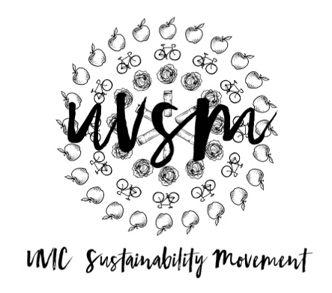

Board Meeting Agenda

October 2, 2017

5:30 PM
Type of Meeting: Board of Directors
Location: Room B028, SUB
Meeting Facilitator: Ryan Suleman
Secretary: Breanna Yaeger
Attendance:
- Call to order
- Acknowledgement of Traditional Territories
Recognizing we are visitors on the traditional unceded Coast Salish territories (Lekwungen & W̱SÁNEĆ peoples)
- Introductions and Check In
- Make Your Own Laundry Detergent Activity
- Board of Directors Retreat
  - October 20-22
  - Can people camp and use sleeping bags or camp elsewhere and join us?
    - Devon to look up vehicle transportation
- Work Study position still available – Administration and Marketing Assistant (100 hours, $13.49/hour)
  - Still taking applications up until oct 13
- Program Updates
  - Finance & Grants
    - Cheque Req Forms
    - Grant Application: SocialCoast Action Bus
      - we could benefit from it! Super rad!
      - All vote in favour! Vote was carried and grant request approved!
      - Ask for follow up photo (second condition lol, first is it has to have a salmon haha )
  - Love My Mug
    - Board of Directors all get a love my mug?
      - Can grab one for free after this meeting
      - We have like 900 left
    - We need like ¼ of the student body to sign the signatures and 1/3 to get noticed and recognition from the university
    - Find the middle ground of not only having cups to go, but also ones that you can have
    - If ubc has it why can’t we? How was that started there? Getting in contact with someone asking what their first steps were.
    - Keep cups, uvic specific label! Made from plastic lids from coffee cups
    - Making another video
      - to promote the petition of banning the paper cup
      - drawing attention to the big problem and then showing our solution… composting
    - like an alternative to a discount to bringing your own mug, like an additional fee to needing a paper cup
    - drafting an email to ubc to find out what they did for next meeting to avoid going back and forth from the same idea’s
    - we need the process ubc used and then we need to adapt that to uvic and what will be the best solution
    - TRU – for composting they have above all their common things on campus that can be put where they belong
    - meeting dedicated to the options once hearing back from ubc
    - following the cup from school and where it ends up for video idea!!! A series of videos?
    - Hormone blockers in certain fast food cups
  - SPUD Food Box / Garden
    - Garden work party earlier today
      - possibly a weekly thing prior to the meeting, go do a little harvesting and then come straight to the meeting and eat whatever is fresh and ready to go!
    - Would people be interested in a watering schedule?
      - signup sheet on our Facebook group
    - SPUD delivery/pick-up days
      - what days work best? Do we continue with Tuesdays and Wednesdays?
      - who is on the spud committee? Let them decide when works best for them
  - Don’t Eat Red Meat
  - Events (Movie Nights, Workshops, etc.)
    - UVERT
      - uvert group can chat and get together and prepare for that
      - we should have a table of cups or a cup table
        - kaia and ryan making a table
  - Campaigns
    - Petition update and brainstorming (see above)
  - Media
    - Social media page active, for each meeting submit what we would like posted on our Instagram
    - Homework find sustainability memes
- Other ideas/thoughts
- Adjournment

