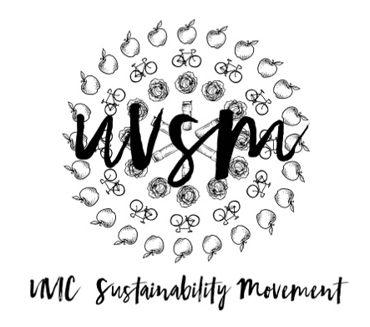

Board Meeting Agenda

October 16, 2017

5:00 PM
Type of Meeting: Board of Directors
Location: Room B028, SUB
Meeting Facilitator: Devon Goldie
Attendance: Joshua, Catie, Breanna, Vince, Jamie, Nicole, Kaia, Ryan, Naomi, Josh, Sienna
- Call to order – 5:37
- Acknowledgement of Traditional Territories
Recognizing we are visitors on the traditional unceded Coast Salish territories (Lekwungen & W̱SÁNEĆ peoples)
- Check In
- Ryan is sick – he will present to us at the retreat endowment lands at UBC which is why they have a no paper cup policy, Indigenous groups had say on what happens on campus and they want a greener campus
- Board of Directors Retreat
  - Transportation- Breanna to drive? Another van?
check rentals for cars with Breanna
- SUB Occupants Committee – need someone to represent UVSM
- Program Updates
  - Finance & Grants
    - Cheque Req Forms
    - Grant Application: Tiny House Warriors – Victoria Buildgrant approved! Post on FB Tiny House Schedule Building
  - SPUD Food Box / Garden
    - Having difficulty with SPUD
  - Don’t Eat Red Meat
  - Events (Movie Nights, Workshops, etc.)
    - Movie Night
      - Partner with Cinecenta for An Inconvenient Sequel (Oct 29 & 30)
      - What do we want to do – Tabling? Which evening? panel in a different room after movie, after 7pm screening on Monday Oct 30
ask professors to come talk, Ryan’s dad, Jeremy Caradonna, Susan Witchita, Elizabeth May, Econ profs
perhaps hold a talk in November when Al Gore is here
have Al Gore come to our meeting and hang out
      - Isn’t time between screenings to do a panel
    - UVERT Debrief
Hartland Landfill Fieldtrip
…UVic pays the landfill to take our garbage so more garbage equals more money for landfilltry to take group on Coastal Bus to see it
Sienna to ask if landfill would be okay with having us there
small group first to go and film, then rest to go and see
Joshua to bring info on German paper cup recycling research
  - Campaigns
    - Love My Mug - Joshua’s Germany model of coffee shops having sit-in mugs for $1 more as a deposit, then they get washed could be implemented at UVic but need dish washers
Love My Mug week this week??? Uvic Office of Campus Planning and Sustainability left us out again…
Contact Matt Greeno about things
create petition on either no paper cups with an alternative (do more research for final idea, possibly finalized on retreat)
  - Media
- Other ideas/thoughts Joshua to send Ryan info on the German paper cup research, Ryan to contact Hartland Landfill, video on paper cups and
- Adjournment … meeting adjourned at 7:00

